\
5/13/2019

Group 1 – The Nerd Herd
Alwyn Barnard (Group leader) 28430093
Anerique van der Walt 28467078
Welmari Odendaal 28975383

ITRW 311
Physical Design
Assignment 3

Table of Contents
1. ER diagram (UML notation) 1
2. Database Objects 2
2.2. Table: KLIENT 2
2.1. Table: CITY 2
2.3. Table: SALES_TRANSACTION 3
2.4. Table: SALES_TRANSACTION_DETAIL 3
2.5. Table:ARTWORK 4
2.6. Table: ART_MEDIUM 5
2.7. Table: COLLECTION 5
2.8. Table: ARTIST 6
2.9. Table: BANK 6
3. Indexes 7
4. Views 7
5. Queries 8
Limitation of rows and columns 8
Sorting 8
LIKE, AND and OR 8
Variables and character functions 9
Round or trunc 9
Date functions 9
Aggregate functions 9
GROUP BY and HAVING 10
JOIN 10
Sub- queries 10

ER diagram (UML notation)
 | COLLECTION
PK | Collection_ID
FK | Artist_ID
 | Collection_Name

 | CITY
PK | City_Code
 | City_Name
 | City_Postal_code

 | CLIENT
PK | Client_ID
FK | City_Code
 | Client_Initial
 | Client_LName
 | Client_RSA_ID
 | Client_Cell
 | Client_Email
 | Client_Street_Adress
 | Street_Nr

 | SALES_TRANSACTION
PK | Transaction_ID
FK | Client_ID
 | Sales_Date
 | Comission
 | VAT
 | Delivery_Method
 | Sales_Total

 | SALES_TRANSACTION_DETAIL
(PK)(FK) | Transaction_ID
(PK)(FK) | Artwork_ID
 | Sales_Price

 | ARTWORK
PK | Artwork_ID
FK | Collection_ID
FK | Medium_Code
 | Artwork_Title
 | Artwork_DOC
 | Length_cm
 | Length_cm
 | Artwork_Status
 | Artwork_Established_Value

 | MEDIUM
PK | Medium_Code
 | Medium_Description

 | ARTIST
PK | Artist_ID
FK | Bank_Code
 | Artist_Initial
 | Artist_LName
 | Artist_RSA_ID
 | Artist_Cell
 | Artist_Email
 | Artist_Account_No
 | Artist_DOB
 | Artist_DOD

 | BANK
PK | Bank_Code
 | Bank_Name

1..1
has
1..*

lives in
1..*
is created
1..1
has
1..*
belongs to
1..1
includes
1..* made from
1..1 used by
1..1 contains
1..* belongs to
1..*
have
1..1
is part of

1..* was created by
1..1 creates
1..*
uses
1..1
has

Database Objects

2.2. Table: KLIENT
This table contains all the personal information about the clients that purchased artwork from the gallery the primary key is client_ID. This table also contains a foreign key: City_Code that connects this table to CITY table.
 | Attributes | Datatypes | Length
PK | Client_ID | NUMBER | 6
FK | City_Code | NUMBER | 6
 | Client_Inits | VARCHAR | 6
 | Client_LName | NUMBER | 30
 | Client_RSA_ID | VARCHAR | 13
 | Client_Cell | VARCHAR | 11
 | Client_Email | VARCHAR | 30
 | Client_Street_Address | VARCHAR | 35
 | Street_Nr | VARCHAR | 5

Constraints
 |  | NOT NULL | Primary key | Foreign key
PK | Client_ID
FK | City_Code
 | Client_Inits
 | Client_LName
 | Client_RSA_ID
 | Client_Cell
 | Client_Email
 | Client_Street_Address
 | Street_Nr

2.1. Table: CITY
Contains a vast variety of different cities within South Africa as well as a corresponding postal code. The table CITY
is connected to the CLIENT table.
 | Attributes | Datatypes | Length
PK | City_Code | NUMBER | 6
 | City_Name | VARCHAR | 30
 | City_Postal_code | VARCHAR | 7

Constraints
 |  | NOT NULL | Unique key | Primary key | Foreign key | Check
PK | City_Code
 | City_Name
 | City_Postal_code

2.3. Table: SALES_TRANSACTION
The SALES_TRANSACTION is the receipt for payment of artwork. It contains the basic information of a receipt.
 | Attributes | Datatypes | Length
PK | Transaction_ID | NUMBER | 6
FK | Client_ID | NUMBER | 6
 | Sales_Date | DATE
 | Comission | NUMBER | 8,2
 | VAT | NUMBER | 5,2
 | Delivery_Method | VARCHAR | 25
 | Sales_Total | NUMBER | 8,2

Constraints
 |  | NOT NULL | Primary key | Foreign key
PK | Transaction_ID
FK | Client_ID
 | Sales_Date
 | Comission
 | VAT
 | Delivery_Method
 | Sales_Total

2.4. Table: SALES_TRANSACTION_DETAIL
Sales transaction detail contains information about the items that was sold.
 | Attributes | Datatypes | Length
(PK)(FK) | Transaction_ID | NUMBER | 6
(PK)(FK) | Artwork_ID | NUMBER | 6
 | Sales_Price | NUMBER | 8,2

Constraints
 |  | NOT NULL | Primary key | Foreign key
(PK)(FK) | Transaction_ID
(PK)(FK) | Artwork_ID
 | Sales_Price

2.5. Table:ARTWORK
This table contains a detailed description of each individual art piece.
 | Attributes | Datatypes | Length
PK | Artwork_ID | NUMBER | 6
FK | Collection_ID | NUMBER | 6
FK | Medium_Code | NUMBER | 6
 | Artwork_Title | VARCHAR | 50
 | Artwork_DOC | DATE
 | Length_cm | INT
 | Width_cm | INT
 | Artwork_Status | VARCHAR | 10
 | Artwork_Established_Value | NUMBER | 8,2

Constraints
 |  | NOT NULL | Primary key | Foreign key
PK | Artwork_ID
FK | Collection_ID
FK | Medium_Code
 | Artwork_Title
 | Artwork_DOC
 | Length_cm
 | Width_cm
 | Artwork_Status
 | Artwork_Established_Value

2.6. Table: ART_MEDIUM
This table contains list of different mediums (paint, photography) used to create artwork and code to uniquely identify the medium.
 | Attributes | Datatypes | Length
PK | Medium_Code | NUMBER | 6
 | Medium_Description | VARCHAR | 30

Constraints
 |  | NOT NULL | Primary key | Foreign key
PK | Medium_Code
 | Medium_Description

2.7. Table: COLLECTION
This table connect the ARTIST table and ARTWORK table and contains the name of each collection.
 | Attributes | Datatypes | Length
PK | Collection_ID | NUMBER | 6
FK | Artist_ID | NUMBER | 6
 | Collection_Name | VARCHAR | 50

Constraints
 |  | NOT NULL | Primary key | Foreign key
PK | Collection_ID
FK | Artist_ID
 | Collection_Name

2.8. Table: ARTIST
This table contains the personal information of each artist that the museum needs for various purposes and for security reasons.
 | Attributes | Datatypes | Length
PK | Artist_ID | NUMBER | 6
FK | Bank_Code | NUMBER | 6
 | Artist_Initial | VARCHAR | 6
 | Artist_LName | VARCHAR | 30
 | Artist_RSA_ID | VARCHAR | 13
 | Artist_Cell | VARCHAR | 11
 | Artist_Email | VARCHAR | 30
 | Artist_Account_No | VARCHAR | 15
 | Artist_DOB | DATE
 | Artist_DOD | DATE

Constraints
 |  | NOT NULL | Primary key | Foreign key
PK | Artist_ID
FK | Bank_Code
 | Artist_Initial
 | Artist_LName
 | Artist_RSA_ID
 | Artist_Cell
 | Artist_Email
 | Artist_Account_No
 | Artist_DOB
 | Artist_DOD

2.9. Table: BANK
This table contains list of different banks and a code to uniquely identify the bank.
 | Attributes | Datatypes | Length
PK | Bank_Code | NUMBER | 6
 | Bank_Name | VARCHAR | 35

Constraints
 |  | NOT NULL | Primary key | Foreign key
PK | Bank_Code
 | Bank_Name

Indexes
Index can be viewed as a structure that exist independent of the data in your table that improves the optimization ability of your query and allows it to execute faster. Indexes is comprised of an index key and a set of pointers
Ordering your table can improve your performance, it makes it easier to find a specific record in a table.
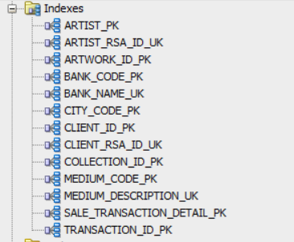

Views
View can be described as the result of a stored query or a summary of a stored query. The database contains the following views – the purpose of each view will be later explained.
- Delivery_List
- Monthly_Sales
- Artwork_In_Collection
- Net_Sales
- Find_Client
- Display_Artwork_Sold
- Display_Living_Artist
- Shipped_Artwork
- Zero_Profit_Sales
- Annual_Sales
- Commission_Goal

STEP ACTIVITY

5. Queries

Limitation of rows and columns
This view will display all artist who has not passed away.
CREATE OR REPLACE VIEW Display_Living_Artist
AS SELECT artist_lname, artist_dob
FROM artist
WHERE artist_dod IS NOT NULL;

Sorting
This view will calculate the age of the artwork by deducting the current date from the date that the artwork was created.

CREATE OR REPLACE VIEW Calculate_Artwork_Age
AS SELECT artwork_id, artwork_title, TO_CHAR(artwork_doc,'DD, "of" MONTH, YYYY') AS "DATE OF CREATION",TO_CHAR(SYSDATE,'YYYY') - TO_CHAR(artwork_doc,'YYYY') AS "ARTWORK_AGE"
FROM ARTWORK
ORDER BY artwork_age DESC;

LIKE, AND and OR
This view will find clients according to their last name, the user will also be prompted to enter the last name
CREATE OR REPLACE VIEW Find_Clients
AS SELECT *
FROM KLIENT WHERE client_lname LIKE '&client_lname%';

This view will only display artwork that must be shipped
CREATE OR REPLACE VIEW Shipped_Artwork
AS SELECT transaction_id,sale_date
FROM sale_transaction
WHERE delivery_method = 'Ship'
OR (delivery_method = 'Ship International');

This view display the transaction where the artwork was sold at a zero profit.
CREATE OR REPLACE VIEW ZERO_PROFIT_SALE
AS SELECT s.transaction_id, s.delivery_method, s.sales_total, d.artwork_id
FROM SALE_TRANSACTION s
INNER JOIN SALE_TRANSACTION_DETAIL d
ON (s.transaction_id = d.transaction_id)
WHERE d.sales_price = s.sales_total
AND s.commission = 0.0;

Variables and character functions
This view will prompt the user to insert a collection ID he/she desires to see. Also known as substitution variable
DEFINE collection_number =1
CREATE OR REPLACE VIEW ARTWORK_IN_COLLECTION
AS SELECT INITCAP(artwork_title) AS "ARTWORK TITLE", artwork_doc AS "DATE OF CREATION", length_cm, width_cm,art_status AS "STATUS", TO_CHAR(art_estimated_value,'L99,999.00') AS "ESTIMATED VALUE"
FROM ARTWORK
WHERE COLLECTION_ID = &collection_number
ORDER BY artwork_doc ASC;
UNDEFINE collection_number;

DEFINE artwork_value =10000
CREATE OR REPLACE VIEW ARTWORK_ESTIMATED_VALUE
AS SELECT INITCAP(artwork_title) AS "ARTWORK TITLE", artwork_doc AS "DATE OF CREATION", length_cm, width_cm,art_status AS "STATUS", TO_CHAR(art_estimated_value,'L99,999.00') AS "ESTIMATED VALUE"
FROM ARTWORK
WHERE art_estimated_value = &artwork_value
ORDER BY artwork_doc ASC;
UNDEFINE artwork_value;

Round or trunc
This view will calculate the annual sales between certain time periods
CREATE OR REPLACE VIEW ANNUAL_SALES
AS SELECT transaction_id,sale_date, sales_total, commission, vat, client_id, delivery_method
FROM sale_transaction
WHERE EXTRACT(YEAR FROM sale_date)
BETWEEN TRUNC(EXTRACT (YEAR FROM SYSDATE)) AND ROUND(EXTRACT (YEAR FROM SYSDATE));

Date functions
This view will calculate the commission goals the museum wants to display
CREATE OR REPLACE VIEW COMMISSION_GOAL
AS SELECT transaction_id,EXTRACT(MONTH FROM TO_DATE(sale_date)) AS "MONTH OF SALE", sales_total, commission, vat
FROM sale_transaction
GROUP BY EXTRACT(MONTH FROM TO_DATE(sale_date)), TO_DATE(sale_date), sale_date, sales_total, transaction_id,
commission, vat
HAVING SUM(sales_total) >= 10000;

Aggregate functions
This view will calculate the sum of the commission, VAT, sales total and net sales
CREATE OR REPLACE VIEW Net_Sales
AS SELECT transaction_id, SUM(commission) AS "Total Commission", SUM(vat) AS "Total VAT" , SUM(sales_total) AS "Total Sales",
TO_CHAR(SUM(sales_total)-SUM(commission)-SUM(vat),'L99,999.00') AS "Net sales"
FROM sale_transaction
WHERE TO_CHAR(sale_date, 'DD') = TO_CHAR(SYSDATE,'DD')
GROUP BY transaction_id;

GROUP BY and HAVING
CREATE OR REPLACE VIEW COMMISSION_GOAL
AS SELECT transaction_id,EXTRACT(MONTH FROM TO_DATE(sale_date)) AS "MONTH OF SALE", sales_total, commission, vat
FROM sale_transaction
GROUP BY EXTRACT(MONTH FROM TO_DATE(sale_date)), TO_DATE(sale_date), sale_date, sales_total, transaction_id,
commission, vat
HAVING SUM(sales_total) >= 10000;

JOIN
This view extracts the data from three tables to show only the relevant information to the deliveryman/ museum about the artwork that needs to be delivered.
CREATE OR REPLACE VIEW DELIVERY_LIST
AS SELECT s.transaction_id, s.delivery_method, INITCAP(c.client_lname) AS "Last Name",
c.client_rsa_id, c.client_cell, c.client_street_address, c.street_nr, t.city_name, t.city_postal_code
FROM SALE_TRANSACTION s
INNER JOIN KLIENT c
ON (s.client_id = c.client_id)
INNER JOIN CITY t
ON (c.city_code = t.city_code);

This view displays only the sales and important information regarding the sales of the current month
CREATE OR REPLACE VIEW MONTHLY_SALES
AS SELECT s.transaction_id, a.artwork_id, t.sale_date, a.artwork_title, c.collection_name, TO_CHAR(s.sales_price,'L99,999.00') AS "Sales Price"
FROM SALE_TRANSACTION_DETAIL s
INNER JOIN SALE_TRANSACTION t
ON (s.transaction_id = t.transaction_id)
INNER JOIN ARTWORK a
ON (s.artwork_id = a.artwork_id)
INNER JOIN COLLECTION c
ON (a.collection_id = c.collection_id)
WHERE TO_CHAR(t.sale_date,'MM') = TO_CHAR(SYSDATE,'MM')
ORDER BY t.sale_date ASC;

Sub- queries
This view will only display artwork that has been sold
CREATE OR REPLACE VIEW Display_Specific_Artwork_Sold
AS SELECT artwork_id,INITCAP(artwork_title) AS "Title"
FROM artwork a
WHERE artwork_id = (SELECT s.artwork_id
FROM sale_transaction_detail s
WHERE s.artwork_id = 2000);

Create Table Queries & Constraints
DROP TABLE ARTIST CASCADE CONSTRAINTS;
DROP TABLE ARTWORK CASCADE CONSTRAINTS;
DROP TABLE BANK CASCADE CONSTRAINTS;
DROP TABLE CITY CASCADE CONSTRAINTS;
DROP TABLE KLIENT CASCADE CONSTRAINTS;
DROP TABLE COLLECTION CASCADE CONSTRAINTS;
DROP TABLE ART_MEDIUM CASCADE CONSTRAINTS;
DROP TABLE SALE_TRANSACTION CASCADE CONSTRAINTS;
DROP TABLE SALE_TRANSACTION_DETAIL CASCADE CONSTRAINTS;

CREATE TABLE BANK(
Bank_Code NUMBER(6) NOT NULL CONSTRAINT bank_code_pk PRIMARY KEY,
Bank_Name VARCHAR(35) NOT NULL,
CONSTRAINT bank_name_uk UNIQUE(Bank_Name)
);

CREATE TABLE ARTIST(
Artist_ID NUMBER(6) NOT NULL ,
Bank_Code NUMBER(6) NOT NULL,
Artist_Inits VARCHAR(6) NOT NULL,
Artist_LName VARCHAR(30) NOT NULL,
Artist_RSA_ID VARCHAR(13) NOT NULL,
Artist_Cell VARCHAR(11) NOT NULL,
Artist_Email VARCHAR(30) NOT NULL,
Artist_Account_No VARCHAR(15) NOT NULL,
Artist_DOB DATE NOT NULL,
Artist_DOD DATE,
CONSTRAINT artist_pk PRIMARY KEY (Artist_ID),
CONSTRAINT bank_code_fk FOREIGN KEY (Bank_Code) REFERENCES BANK(Bank_Code),
CONSTRAINT artist_rsa_id_uk UNIQUE(Artist_RSA_ID)
);

CREATE TABLE COLLECTION(
Collection_ID NUMBER(6) NOT NULL,
Artist_ID NUMBER(6)NOT NULL,
Collection_Name VARCHAR(50) NOT NULL,
CONSTRAINT collection_id_pk PRIMARY KEY (Collection_ID),
CONSTRAINT artist_id_fk FOREIGN KEY (Artist_ID) REFERENCES ARTIST(Artist_ID)
);

CREATE TABLE ART_MEDIUM(
Medium_Code NUMBER(6) NOT NULL,
Medium_Description VARCHAR(30) NOT NULL,
CONSTRAINT medium_code_pk PRIMARY KEY (Medium_Code),
CONSTRAINT medium_description_uk UNIQUE(Medium_Description)
);

CREATE TABLE ARTWORK(
Artwork_ID NUMBER(6) NOT NULL,
Collection_ID NUMBER(6) NOT NULL,
Medium_Code NUMBER(6) NOT NULL,
Artwork_Title VARCHAR(50) NOT NULL,
Artwork_DOC DATE NOT NULL,
Length_cm INT NOT NULL,
Width_cm INT NOT NULL,
Art_Status VARCHAR(10) NOT NULL,
Art_Estimated_Value NUMBER(8) NOT NULL,
CONSTRAINT artwork_id_pk PRIMARY KEY (Artwork_ID),
CONSTRAINT collection_id_fk FOREIGN KEY (Collection_ID) REFERENCES COLLECTION(Collection_ID),
CONSTRAINT medium_code_fk FOREIGN KEY (Medium_Code) REFERENCES ART_MEDIUM(Medium_Code),
CONSTRAINT artwork_estimated_value_min CHECK(Art_Estimated_Value >0),
CONSTRAINT length_min CHECK(Length_cm >0),
CONSTRAINT width_min CHECK(Width_cm >0)
);

CREATE TABLE CITY(
City_Code NUMBER(6) NOT NULL,
City_Name VARCHAR(30) NOT NULL,
City_Postal_Code VARCHAR(7) NOT NULL,
CONSTRAINT city_code_pk PRIMARY KEY (City_Code)
);

CREATE TABLE KLIENT(
Client_ID NUMBER(6) NOT NULL,
City_Code NUMBER(6)NOT NULL,
Client_Inits VARCHAR(6) NOT NULL,
Client_LName VARCHAR(30) NOT NULL,
Client_RSA_ID VARCHAR(13) NOT NULL,
CLient_Cell VARCHAR(11) NOT NULL,
Client_Email VARCHAR(30) NOT NULL,
Client_Street_Address VARCHAR(35) NOT NULL,
Street_Nr VARCHAR(5) NOT NULL,
CONSTRAINT client_id_pk PRIMARY KEY (Client_ID),
CONSTRAINT city_code_fk FOREIGN KEY (City_Code) REFERENCES CITY(City_Code),
CONSTRAINT client_rsa_id_uk UNIQUE(Client_RSA_ID)
);

CREATE TABLE SALE_TRANSACTION(
Transaction_ID NUMBER(6) NOT NULL,
Client_ID NUMBER(6)NOT NULL,
Sale_Date DATE NOT NULL,
Commission NUMBER(8,2) NOT NULL,
VAT NUMBER(5,2) NOT NULL,
Delivery_Method VARCHAR(25) NOT NULL,
Sales_Total NUMBER(8,2) NOT NULL,
CONSTRAINT transaction_id_pk PRIMARY KEY (Transaction_ID),
CONSTRAINT client_id_fk FOREIGN KEY (Client_ID) REFERENCES KLIENT(Client_ID),
CONSTRAINT sale_total_ck CHECK(Sales_Total > 0)
);

CREATE TABLE SALE_TRANSACTION_DETAIL(
Transaction_ID NUMBER(6) NOT NULL,
Artwork_ID NUMBER(6) NOT NULL,
Sales_Price NUMBER(8,2) NOT NULL,
CONSTRAINT sale_transaction_detail_pk PRIMARY KEY(Transaction_ID, Artwork_ID),
CONSTRAINT transaction_id_fk FOREIGN KEY (Transaction_ID) REFERENCES SALE_TRANSACTION(Transaction_ID),
CONSTRAINT artwork_id_fk FOREIGN KEY (Artwork_ID) REFERENCES ARTWORK(Artwork_ID),
CONSTRAINT sales_price_min CHECK(Sales_Price>0)
);

CREATE SEQUENCE artist_id_seq
START WITH 1
INCREMENT BY 1
MAXVALUE 1000;

CREATE SEQUENCE collection_id_seq
START WITH 1000
INCREMENT BY 1
MAXVALUE 2000;

CREATE SEQUENCE artwork_id_seq
START WITH 2000
INCREMENT BY 1
MAXVALUE 3000;

CREATE SEQUENCE city_id_seq
START WITH 16000
INCREMENT BY 1
MAXVALUE 17000;

CREATE SEQUENCE bank_id_seq
START WITH 14000
INCREMENT BY 1
MAXVALUE 15000;

CREATE SEQUENCE art_medium_id_seq
START WITH 4000
INCREMENT BY 1
MAXVALUE 5000;

CREATE SEQUENCE transaction_id_seq
START WITH 12000
INCREMENT BY 1
MAXVALUE 13000;

CREATE SEQUENCE klient_id_seq
START WITH 10000
INCREMENT BY 1
MAXVALUE 11000;

Insert Statements
BANK TABLE
INSERT INTO "TAMOA"."BANK" (BANK_CODE, BANK_NAME) VALUES ('14000', 'Capitect Bank');
INSERT INTO "TAMOA"."BANK" (BANK_CODE, BANK_NAME) VALUES (BANK_ID_SEQ.nextval, 'Standard Bank');
INSERT INTO "TAMOA"."BANK" (BANK_CODE, BANK_NAME) VALUES (BANK_ID_SEQ.nextval, 'First National Bank');
INSERT INTO "TAMOA"."BANK" (BANK_CODE, BANK_NAME) VALUES (BANK_ID_SEQ.nextval, 'Swiss International');
INSERT INTO "TAMOA"."BANK" (BANK_CODE, BANK_NAME) VALUES (BANK_ID_SEQ.nextval, 'Caymin Islands Bank');
INSERT INTO "TAMOA"."BANK" (BANK_CODE, BANK_NAME) VALUES (BANK_ID_SEQ.nextval, 'African Bank');
INSERT INTO "TAMOA"."BANK" (BANK_CODE, BANK_NAME) VALUES (BANK_ID_SEQ.nextval, 'Bank of America');

ARTIST TABLE
INSERT INTO "TAMOA"."ARTIST" (ARTIST_ID, BANK_CODE, ARTIST_INITS, ARTIST_LNAME, ARTIST_RSA_ID, ARTIST_CELL, ARTIST_EMAIL,
ARTIST_ACCOUNT_NO, ARTIST_DOB) VALUES ('1', '14000', 'P', 'Parker', '9802225117085', '27864853203',
'peter.parker@spiderman.com', '2486152535', TO_DATE('1998-02-22', 'YYYY-MM-DD'));
INSERT INTO "TAMOA"."ARTIST" (ARTIST_ID, BANK_CODE, ARTIST_INITS, ARTIST_LNAME, ARTIST_RSA_ID, ARTIST_CELL, ARTIST_EMAIL,
ARTIST_ACCOUNT_NO, ARTIST_DOB) VALUES (ARTIST_ID_SEQ.nextval, '14003', 'RJ', 'Steele', '8811185117080', '27864853203',
'steel.rhino@gmail.com', '2486152535', TO_DATE('1988-11-18', 'YYYY-MM-DD'));
INSERT INTO "TAMOA"."ARTIST" (ARTIST_ID, BANK_CODE, ARTIST_INITS, ARTIST_LNAME, ARTIST_RSA_ID, ARTIST_CELL, ARTIST_EMAIL,
ARTIST_ACCOUNT_NO, ARTIST_DOB) VALUES (ARTIST_ID_SEQ.nextval, '14004', 'M', 'Eros', '7401083113030', '27631840320',
'erosM@yahoomail.com', '2486152535', TO_DATE('1974-01-08', 'YYYY-MM-DD'));
INSERT INTO "TAMOA"."ARTIST" (ARTIST_ID, BANK_CODE, ARTIST_INITS, ARTIST_LNAME, ARTIST_RSA_ID, ARTIST_CELL, ARTIST_EMAIL,
ARTIST_ACCOUNT_NO, ARTIST_DOB) VALUES (ARTIST_ID_SEQ.nextval, '14006', 'L', 'Laas', '6105305117085', '27846274141',
'LL.laas@kantilla.com', '2486152535', TO_DATE('1961-05-30', 'YYYY-MM-DD'));
INSERT INTO "TAMOA"."ARTIST" (ARTIST_ID, BANK_CODE, ARTIST_INITS, ARTIST_LNAME, ARTIST_RSA_ID, ARTIST_CELL, ARTIST_EMAIL,
ARTIST_ACCOUNT_NO, ARTIST_DOB) VALUES (ARTIST_ID_SEQ.nextval, '14002', 'E', 'Cent', '6601135117085', '27876489595',
'50cent.EC@wraps.com', '2486152535', TO_DATE('1966-01-13', 'YYYY-MM-DD'));
INSERT INTO "TAMOA"."ARTIST" (ARTIST_ID, BANK_CODE, ARTIST_INITS, ARTIST_LNAME, ARTIST_RSA_ID, ARTIST_CELL, ARTIST_EMAIL,
ARTIST_ACCOUNT_NO, ARTIST_DOB) VALUES (ARTIST_ID_SEQ.nextval, '14001', 'Q', 'Poole', '9005055117085', '27626896113',
'pooleQ@hippo.com', '2486152535', TO_DATE('1990-05-05', 'YYYY-MM-DD'));

COLLECTION TABLE
INSERT INTO "TAMOA"."COLLECTION" (COLLECTION_ID, ARTIST_ID, COLLECTION_NAME) VALUES ('1000', '2', 'Halogen Records');
INSERT INTO "TAMOA"."COLLECTION" (COLLECTION_ID, ARTIST_ID, COLLECTION_NAME) VALUES
(COLLECTION_ID_SEQ.nextval, '5', 'The Amusing Pea');
INSERT INTO "TAMOA"."COLLECTION" (COLLECTION_ID, ARTIST_ID, COLLECTION_NAME) VALUES
(COLLECTION_ID_SEQ.nextval, '4', 'Master Suite');
INSERT INTO "TAMOA"."COLLECTION" (COLLECTION_ID, ARTIST_ID, COLLECTION_NAME) VALUES
(COLLECTION_ID_SEQ.nextval, '1', 'Docking');
INSERT INTO "TAMOA"."COLLECTION" (COLLECTION_ID, ARTIST_ID, COLLECTION_NAME) VALUES
(COLLECTION_ID_SEQ.nextval, '5', 'Culture Shock');

ART_MEDIUM TABLE
INSERT INTO "TAMOA"."ART_MEDIUM" (MEDIUM_CODE, MEDIUM_DESCRIPTION) VALUES ('4000', 'Stone Carving');
INSERT INTO "TAMOA"."ART_MEDIUM" (MEDIUM_CODE, MEDIUM_DESCRIPTION) VALUES (ART_MEDIUM_ID_SEQ.nextval, 'Wood Print');
INSERT INTO "TAMOA"."ART_MEDIUM" (MEDIUM_CODE, MEDIUM_DESCRIPTION) VALUES (ART_MEDIUM_ID_SEQ.nextval, 'Painting');
INSERT INTO "TAMOA"."ART_MEDIUM" (MEDIUM_CODE, MEDIUM_DESCRIPTION) VALUES (ART_MEDIUM_ID_SEQ.nextval, 'Ink Print');
INSERT INTO "TAMOA"."ART_MEDIUM" (MEDIUM_CODE, MEDIUM_DESCRIPTION) VALUES (ART_MEDIUM_ID_SEQ.nextval, 'Glass Sculpture');

ARTWORK TABLE
INSERT INTO "TAMOA"."ARTWORK" (ARTWORK_ID, COLLECTION_ID, MEDIUM_CODE, ARTWORK_TITLE, ARTWORK_DOC, LENGTH_CM, WIDTH_CM,
ART_STATUS, ART_ESTIMATED_VALUE) VALUES ('2000', '1003', '4002', 'A Painting of Hal',
TO_DATE('1999-06-08', 'YYYY-MM-DD'), '200', '60', 'For Sale', '20000');
INSERT INTO "TAMOA"."ARTWORK" (ARTWORK_ID, COLLECTION_ID, MEDIUM_CODE, ARTWORK_TITLE, ARTWORK_DOC, LENGTH_CM, WIDTH_CM,
ART_STATUS, ART_ESTIMATED_VALUE) VALUES (ARTWORK_ID_SEQ.nextval, '1004', '4000', 'Eloquence',
TO_DATE('1958-11-08', 'YYYY-MM-DD'), '100', '30', 'For Sale', '40000');
INSERT INTO "TAMOA"."ARTWORK" (ARTWORK_ID, COLLECTION_ID, MEDIUM_CODE, ARTWORK_TITLE, ARTWORK_DOC, LENGTH_CM, WIDTH_CM,
ART_STATUS, ART_ESTIMATED_VALUE) VALUES (ARTWORK_ID_SEQ.nextval, '1001', '4004', 'Beast',
TO_DATE('2007-03-20', 'YYYY-MM-DD'), '40', '500', 'For Sale', '65000');
INSERT INTO "TAMOA"."ARTWORK" (ARTWORK_ID, COLLECTION_ID, MEDIUM_CODE, ARTWORK_TITLE, ARTWORK_DOC, LENGTH_CM, WIDTH_CM,
ART_STATUS, ART_ESTIMATED_VALUE) VALUES (ARTWORK_ID_SEQ.nextval, '1000', '4001', 'Forward 1',
TO_DATE('2010-01-30', 'YYYY-MM-DD'), '3', '880', 'For Sale', '3500');
INSERT INTO "TAMOA"."ARTWORK" (ARTWORK_ID, COLLECTION_ID, MEDIUM_CODE, ARTWORK_TITLE, ARTWORK_DOC, LENGTH_CM, WIDTH_CM,
ART_STATUS, ART_ESTIMATED_VALUE) VALUES (ARTWORK_ID_SEQ.nextval, '1002', '4000', 'Foot',
TO_DATE('2000-06-11', 'YYYY-MM-DD'), '80', '1000', 'For Sale', '70000');

SALE_TRANSACTION TABLE
INSERT INTO "TAMOA"."SALE_TRANSACTION" (TRANSACTION_ID, CLIENT_ID, SALE_DATE, COMMISSION, VAT, DELIVERY_METHOD, SALES_TOTAL)
VALUES ('12001', '10000', TO_DATE('2019-05-07', 'YYYY-MM-DD'), '10000', '11200', 'Deliver', '80000');
INSERT INTO "TAMOA"."SALE_TRANSACTION" (TRANSACTION_ID, CLIENT_ID, SALE_DATE, COMMISSION, VAT, DELIVERY_METHOD, SALES_TOTAL)
VALUES (TRANSACTION_ID_SEQ.nextval, '10001', TO_DATE('2018-03-07', 'YYYY-MM-DD'), '10000', '11200', 'Pick Up', '80000');
INSERT INTO "TAMOA"."SALE_TRANSACTION" (TRANSACTION_ID, CLIENT_ID, SALE_DATE, COMMISSION, VAT, DELIVERY_METHOD, SALES_TOTAL)
VALUES (TRANSACTION_ID_SEQ.nextval, '10002', TO_DATE('2019-02-07', 'YYYY-MM-DD'), '10000', '11200', 'Storage', '80000');
INSERT INTO "TAMOA"."SALE_TRANSACTION" (TRANSACTION_ID, CLIENT_ID, SALE_DATE, COMMISSION, VAT, DELIVERY_METHOD, SALES_TOTAL)
VALUES (TRANSACTION_ID_SEQ.nextval, '10003', TO_DATE('2019-01-13', 'YYYY-MM-DD'), '10000', '11200', 'Ship', '80000');
INSERT INTO "TAMOA"."SALE_TRANSACTION" (TRANSACTION_ID, CLIENT_ID, SALE_DATE, COMMISSION, VAT, DELIVERY_METHOD, SALES_TOTAL)
VALUES (TRANSACTION_ID_SEQ.nextval, '10004', TO_DATE('2018-12-09', 'YYYY-MM-DD'), '10000', '11200', 'Ship International', '80000');

SALE_TRANSACTION_DETAIL TABLE
INSERT INTO "TAMOA"."SALE_TRANSACTION_DETAIL" (TRANSACTION_ID, ARTWORK_ID, SALES_PRICE) VALUES ('12000', '2000', '75000');
INSERT INTO "TAMOA"."SALE_TRANSACTION_DETAIL" (TRANSACTION_ID, ARTWORK_ID, SALES_PRICE) VALUES (TRANSACTION_ID_SEQ.nextval, '2001', '75000');
INSERT INTO "TAMOA"."SALE_TRANSACTION_DETAIL" (TRANSACTION_ID, ARTWORK_ID, SALES_PRICE) VALUES (TRANSACTION_ID_SEQ.nextval, '2002', '75000');
INSERT INTO "TAMOA"."SALE_TRANSACTION_DETAIL" (TRANSACTION_ID, ARTWORK_ID, SALES_PRICE) VALUES (TRANSACTION_ID_SEQ.nextval, '2003', '75000');

Data on Tables
CITY Table
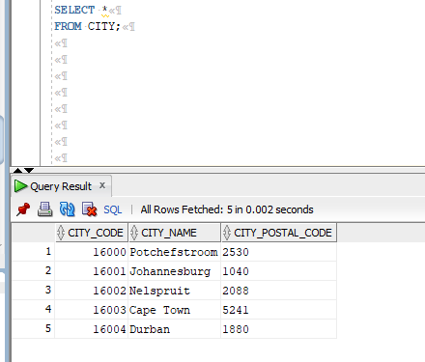
KLIENT Table
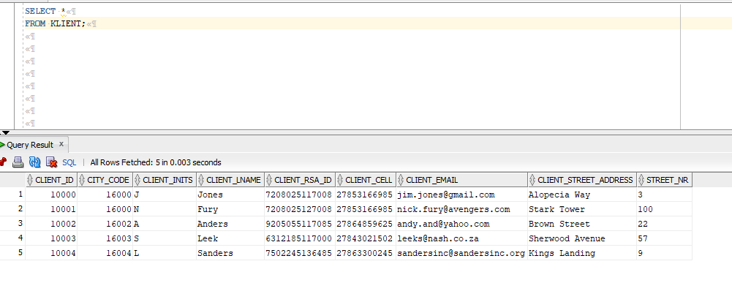

SALES_TRANSACTION Table
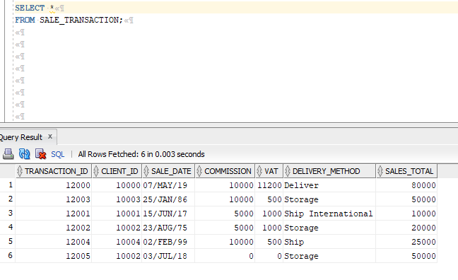

SALE_TRANSACTION_DETAIL Table
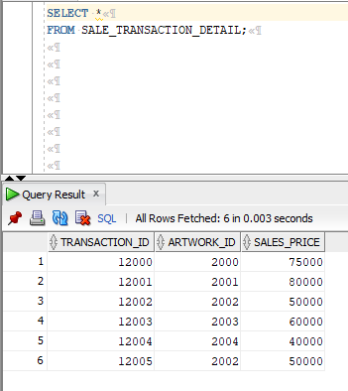

ARTWORK Table
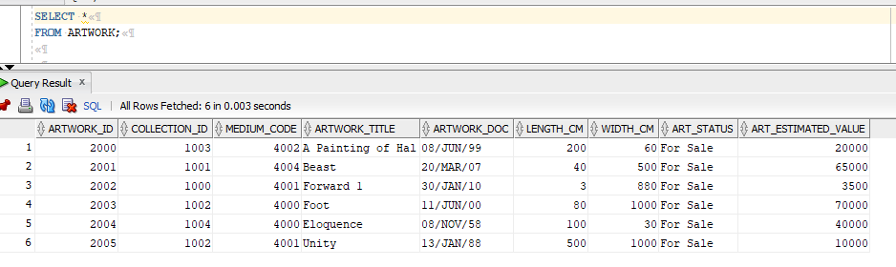
COLLECTION Table
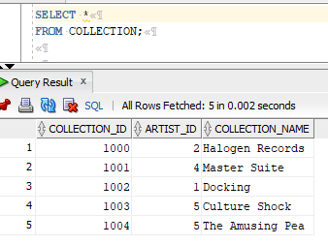
ART_MEDIUM Table
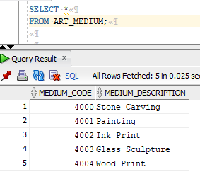

ARTIST Table
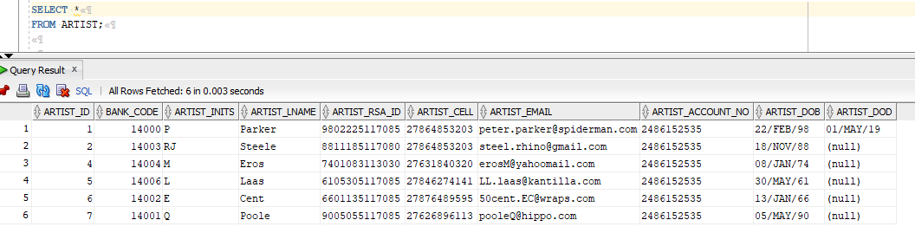

BANK Table
